Gavriel Miles

IGME 202 03

Documentation: Project 4 - Part B

This project is the second part of a Humans vs. Zombies simulation made in Unity. On start, the simulation begins with four humans and one zombie on a desert terrain with eight randomly positioned objects.

Explanation of controls are on the right side of the screen, which direction the user to click on the buttons on the left side to spawn more humans or zombies-- this is the above and beyond “interactive” component to the project.

No game-breaking bugs are known. Requirements are completed, though some might be considered “partially” completed because of not always working as expected. Additionally, the graphics in the executable, though still working, did not turn out as intended due to some unforeseen complications with anchors. Below is how I intended my screen to appear:

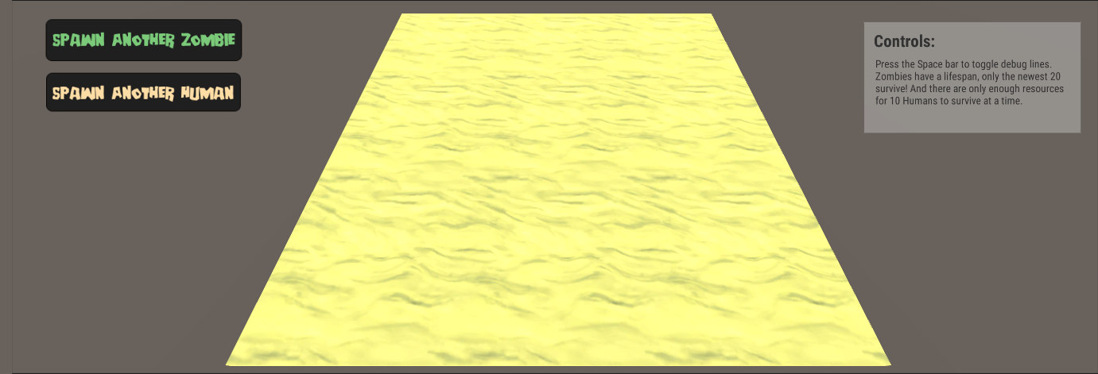

Below are the resources I utilized for this project:

Human: <https://assetstore.unity.com/packages/3d/characters/humanoids/character-pack-free-sample-79870>

Zombie: <https://assetstore.unity.com/packages/3d/characters/humanoids/character-pack-zombie-sample-131604>

Rocks:

<https://assetstore.unity.com/packages/3d/props/exterior/low-poly-styled-rocks-43486>

Textures:

<https://assetstore.unity.com/packages/2d/textures-materials/floors/five-seamless-tileable-ground-textures-57060>

Fonts:

Deanna: <https://www.1001fonts.com/deanna-font.html>

Roboto Condensed: <https://fonts.google.com/selection?selection.family=Roboto+Condensed>

Lastly, I used my grace period for this project!